Data Structures – CS 3305

**Final Project Deliverable**

*Notes I got from speaking with the professor about the Final Project.

* The goal is to segment any image using graphs/changing the code that is provided. A ZIP file has also been attached to the email that was sent with this document called “proj”.
* The **professor has made it a point** that he does not care how well your image is segmented or looks. He primarily wants everyone to **try to understand** how the code works and **attempt to make their own changes**, using the slides provided.

* Inside the “segment” folder you will see a lot of code files that you will use for the Final Project. See image below:

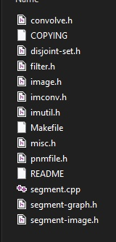

* The **only files that you will modify** are the bottom **three** which include:  
    
  segment.cpp  
  segment-graph.h  
  segment-image.h
* The code in its current state should compile. You can run the code and follow the directions in the README file (open with notepad). In order to use image segmentation you must **insert any image** of your choosing to the root directory where the rest of the code files are located(the image above is where the root directory is located).
* The image **must be in .ppm format**. If it is a .jpeg or .png then it must be converted first before inserting into the root directory.
* When running through the output make sure to name your new image a different name than the original.
* Example of original vs segmented image below:

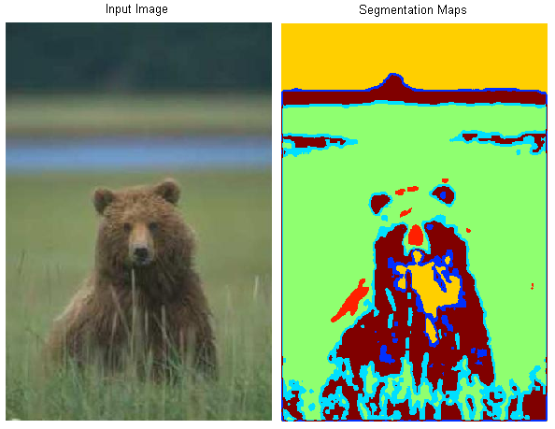

**What to Submit**

With the images added to the root directory and changes made to the code, you will save the whole solution/project into a ZIP file and submit.